NETWORK ID

Network ID :

A network ID, or Network Address, is the portion of an IP address that identifies a specific network. It is shared by all devices on the same network, allowing routers to direct traffic to the correct destination. The other portion of an IP address is the Host ID, which identifies a unique device within that network.

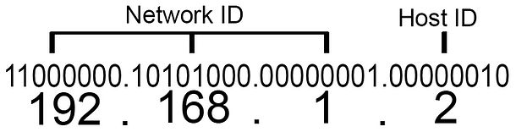

How network IDs work with IPv4

In IPv4, a 32-bit IP address is divided into the network and host portions. A subnet mask is used to distinguish the network ID from the host ID by masking the network portion with all 1s and the host portion with all 0s.

The size of the network ID depends on the addressing scheme:

* Classful addressing: This older system uses the first bits of an IP address to determine its class, which sets a fixed boundary for the network ID.
  + Class A: The first octet is the network ID (e.g., in 72.0.0.0, 72 is the network ID).
  + Class B: The first two octets are the network ID (e.g., 128.168.0.0).
  + Class C: The first three octets are the network ID (e.g., 192.168.1.0).
* Classless Inter-Domain Routing (CIDR): This more modern and flexible system uses a suffix (e.g., /24) to specify the number of bits in the network ID, allowing for more efficient use of the IP address space.

A simple example is a street address:

* Network ID: The street name and town. All houses on the same street share the same network ID.
* Host ID: The unique house number. Each house on the street has a different number.

How the two IDs work together

If your computer has the IP address 192.168.1.10 and the network ID is 192.168.1.0, here's how it breaks down:

* 192.168.1: This is the network ID. All devices in this home network—like your smart TV, phone, and laptop—will start with this same set of numbers.
* 10: This is the host ID. It is the unique number assigned to your specific computer within the network.